The Crystal Apothecary: Healing Remedies for Mind, Body & Spirit

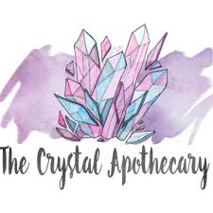

By AF Crystal Jewels

Personal Note from AF Crystal Jewels

Dear Andrea,

Welcome to The Crystal Apothecary!

Crystals have been an essential part of my personal healing journey, helping me find balance, clarity, and strength. Whether you’re just starting or deepening your crystal practice, this book is designed to be your trusted guide—a collection of wisdom, rituals, and practical tools to bring crystal healing into your daily life.

I believe that healing is a deeply personal journey, and crystals are here to support you every step of the way. Through these pages, I invite you to explore, experiment, and trust your intuition as you unlock the power of crystal energy.

May this book bring you peace, transformation, and empowerment.

With love & light,

AF Crystal Jewels

Chapter 1: The Foundations of Crystal Healing

How Crystals Work: Understanding Their Energy

Crystals are powerful energy conductors that interact with our body’s natural vibration. Their stable molecular structure allows them to absorb, store, and emit energy, making them excellent tools for healing and spiritual growth.

Did You Know?

Every crystal has a unique vibrational frequency, which is why some stones (like amethyst) calm the mind, while others (like Citrine) boost energy.

Crystal Energy Frequency Chart

|  |  |  |
| --- | --- | --- |
| **Crystal** | **Vibrational Properties** | **Best Use** |
| Clear Quartz | Amplifies energy & intentions | Meditation, manifestation |
| Amethyst | Calms the mind & reduces stress | Sleep, relaxation |
| Citrine | Boosts motivation & abundance | Prosperity, creativity |
| Black Tourmaline | Grounds & protects | Shields from negativity |
| Rose Quartz | Encourages love & self-care | Emotional healing |

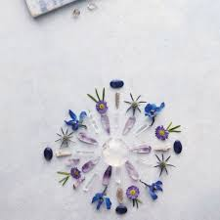

Chapter 2: Crystals for Emotional Balance & Mental Clarity

Crystals for Stress, Anxiety & Inner Peace

Life can be overwhelming, but certain crystals help restore emotional balance and promote a sense of calm.

Top Crystals for Stress Relief:

 Amethyst – Reduces anxiety and overthinking

 Lepidolite – Naturally contains lithium, which helps stabilize mood

 Rose Quartz – Promotes emotional healing and self-love

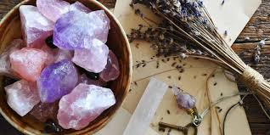Quick Stress-Relief Ritual

You’ll Need:

• A small amethyst or lepidolite stone

• A quiet space

Steps:

1. Hold the crystal in your palm and take a deep breath.
2. Close your eyes and visualize a soft violet light surrounding you.
3. Repeat: “I am calm. I am safe. I am at peace.”
4. Exhale and release any stress.

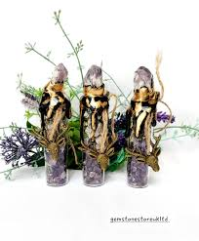Pro Tip: Keep a small amethyst in your pocket or under your pillow for continuous calming energy.

Chapter 3: Crystals for Physical Healing

Using Crystal-Infused Healing Water (Elixirs)

Crystal-infused water allows you to absorb the healing properties of gemstones in a gentle and effective way. However, not all crystals are water-safe!

 **Safety Warning: Some crystals contain toxic elements that should NOT be placed in water, such as malachite, selenite, pyrite, and lapis lazuli.**

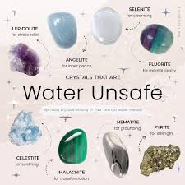

Here are 45 toxic gemstone/crystals NOT to be used as elixirs…

https://shop.atperrys.com/blogs/healing-crystals-blog/45-toxic-gemstones-not-to-use-in-gem-elixirs-with-facts?srsltid=AfmBOopPST3sUrnhcsr4s5dCrO38zV0rhroUaeFa56fESXwz5sIXEerO

How to Make a Crystal Elixir

You’ll Need:

• A water-safe crystal (such as clear quartz, amethyst, or rose quartz)

• A glass jar with purified water

• Sunlight or moonlight for charging

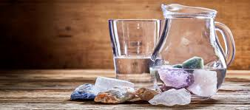

Steps:

 Place the crystal in the jar.

 Let it sit in direct sunlight for 4 hours (for energy-boosting) or under the full moon overnight (for emotional healing).

 Remove the crystal and drink the water mindfully.

Chapter 4: Crystals for Spiritual Growth & Protection

How to Use Crystals for Chakra Balancing

Our body has seven main chakras—energy centres that regulate our emotional, physical, and spiritual health. When a chakra is blocked, we may experience emotional imbalances, fatigue, or stress. Crystals help restore harmony to each chakra.

Chakra & Crystal Guide

|  |  |  |  |
| --- | --- | --- | --- |
| **Chakra** | **Colour** | **Best Crystal** | **Healing Benefit** |
| Crown (Spirituality) | Violet | Amethyst | Enhances intuition & wisdom |
| Third Eye (Intuition) | Indigo | Lapis Lazuli | Expands awareness & focus |
| Throat (Communication) | Blue | Sodalite | Encourages truth & clarity |
| Heart (Love) | Green/Pink | Rose Quartz | Opens the heart to love |
| Solar Plexus (Confidence) | Yellow | Citrine | Boosts motivation & personal power |
| Sacral (Creativity) | Orange | Carnelian | Awakens passion & creativity |
| Root (Grounding) | Red/Black | Black Tourmaline | Provides security & stability |

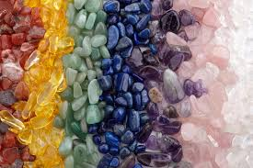

Chapter 5: Sacred Crystal Rituals

Daily Protection Ritual with Crystals

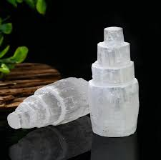

You’ll Need:

• Black Tourmaline (for protection)

• Selenite (for cleansing)

Steps:

 Hold black tourmaline in your hand and set the intention:

“I am shielded from negative energy. I am protected.”

 Wave a selenite wand around your body to clear any stagnant energy.

 Place black tourmaline near your front door for ongoing protection.

 Tip: If you work in a stressful environment, keep black tourmaline at your desk to deflect negativity.

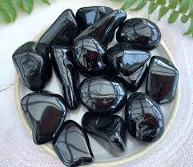

Final Thoughts

Crystal healing is a lifelong journey—one that evolves as you grow. Whether you’re using crystals for emotional support, spiritual awakening, or physical healing, the key is to trust your intuition and enjoy the process.

Thank you for allowing AF Crystal Jewels to be part of your healing path.

