**Power of Crystals for Spiritual Growth and Well-Being eBook**

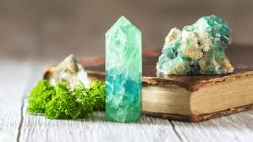

**Created by Roxy Slabber**

**AF Crystal Jewels – Aura Flora Crystal Jewels**

**Table of Contents**

1. Introduction to Crystal Healing
2. How Crystals Work: Energy and Vibrations

3. Essential Crystals and Their Spiritual Meanings

• Clear Quartz

• Amethyst

• Rose Quartz

• Citrine

• Black Tourmaline

• Lapis Lazuli

• Tiger’s Eye

• Carnelian

• Selenite

1. Crystal Uses in Daily Life

• Meditation

• Chakra Balancing

• Protection and Grounding

• Manifestation and Abundance

• Emotional Healing

1. Cleansing and Charging Your Crystals
2. Building Your Crystal Collection

7. Conclusion and Next Steps

**Introduction to Crystal Healing**

For centuries, civilizations across the world have harnessed the power of crystals for spiritual growth, emotional balance, and physical well-being. From the ancient Egyptians to Eastern healers, crystals have been revered for their ability to channel energy and promote harmony.

In this guide, you’ll discover the unique properties of various crystals, their meanings, and practical ways to incorporate them into your daily life for healing and manifestation.

**How Crystals Work: Energy and Vibrations**

Crystals are natural formations that possess unique vibrational frequencies. These frequencies interact with the energy fields (also known as auras) of living beings, helping to balance, cleanse, and amplify energy. By working with crystals, you can enhance your emotional well-being, deepen your meditation practice, and even manifest positive changes in your life.

**Essential Crystals and Their Spiritual Meanings**

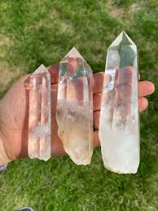

**1. Clear Quartz – The Master Healer**

• **Spiritual Meaning:** Clarity, energy amplification, and balance

• **Uses:** Enhances meditation, clears negative energy, and amplifies intentions

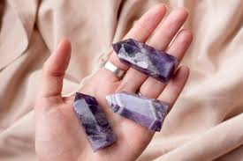

**2. Amethyst – The Stone of Spiritual Protection**

• **Spiritual Meaning:** Intuition, calmness, and spiritual growth

• **Uses:** Enhances intuition, relieves stress, and aids in restful sleep

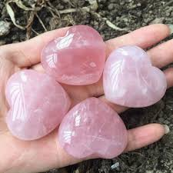

**3. Rose Quartz – The Stone of Love**

• **Spiritual Meaning:** Unconditional love, compassion, and emotional healing

• **Uses:** Attracts love, heals heart chakra, and promotes self-love

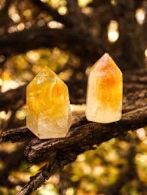

**4. Citrine – The Stone of Abundance**

• **Spiritual Meaning:** Prosperity, creativity, and positive energy

• **Uses:** Attracts wealth, boosts confidence, and encourages creativity

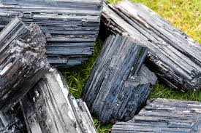**5. Black Tourmaline – The Protector**

• **Spiritual Meaning:** Grounding, protection, and cleansing

• **Uses:** Shields against negative energy, provides grounding, and relieves stress

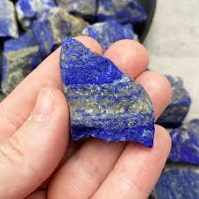**6. Lapis Lazuli – The Stone of Wisdom**

• **Spiritual Meaning:** Truth, self-awareness, and communication

• **Uses:** Enhances spiritual insight, supports communication, and strengthens intuition

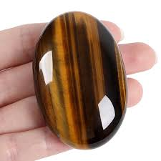**7. Tiger’s Eye – The Stone of Courage**

• **Spiritual Meaning:** Strength, confidence, and protection

• **Uses:** Boosts self-confidence, enhances willpower, and protects against negative influences

**8. Carnelian – The Stone of Passion**

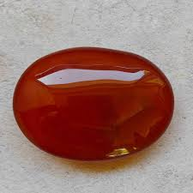• **Spiritual Meaning:** Creativity, vitality, and motivation

• **Uses:** Boosts creativity, enhances physical energy, and promotes confidence

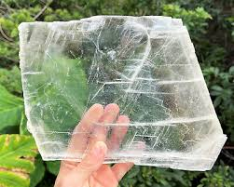**9. Selenite – The Purifier**

• **Spiritual Meaning:** Clarity, purification, and spiritual connection

• **Uses:** Cleanses energy, enhances meditation, and connects with higher realms

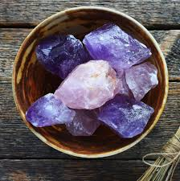

**Crystal Uses in Daily Life**

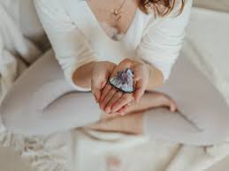

Crystals can be powerful tools for personal transformation when incorporated into daily routines. By working with their unique vibrations, you can enhance your mental clarity, emotional balance, and spiritual connection. Here’s how to effectively use crystals in various aspects of life:

**1. Meditation and Mindfulness**

Crystals can help deepen your meditation practice by enhancing focus and promoting inner peace.

• **Recommended Crystals:** Amethyst (for intuition), Clear Quartz (for clarity), and Selenite (for spiritual connection).

• **How to Use:** Hold the crystal in your hand or place it on your third eye or heart chakra during meditation. Focus on your breath and allow the crystal’s energy to align with your intentions.

**2. Chakra Balancing**

Each crystal resonates with specific chakras (energy centers in the body). Balancing these chakras can enhance your physical and emotional well-being.

• **Root Chakra (Grounding):** Black Tourmaline or Red Jasper

• **Heart Chakra (Love):** Rose Quartz or Green Aventurine

• **Third Eye Chakra (Intuition):** Lapis Lazuli or Amethyst

• **How to Use:** Place the corresponding crystal on the chakra point while lying down. Visualize the energy flowing and clearing blockages.

**3. Protection and Grounding**

Crystals act as shields against negative energy and help maintain emotional balance.

• **Recommended Crystals:** Black Tourmaline (for protection), Hematite (for grounding), and Obsidian (for energy shielding).

• **How to Use:** Carry the crystal in your pocket, wear it as jewelry, or place it at the entrance of your home.

**4. Manifestation and Abundance**

Crystals can amplify your intentions and attract prosperity.

• **Recommended Crystals:** Citrine (for abundance), Pyrite (for wealth), and Green Jade (for success).

• **How to Use:** Write your intention on a piece of paper, place the crystal on top, and keep it in a sacred space. Visualize your goals as already achieved.

**5. Emotional Healing and Self-Love**

Crystals can support emotional release and foster compassion and self-love.

• **Recommended Crystals:** Rose Quartz (for love), Rhodonite (for emotional balance), and Moonstone (for emotional clarity).

• **How to Use:** Wear the crystal as a pendant or keep it close to your heart during moments of self-reflection.

**Cleansing and Charging Your Crystals**

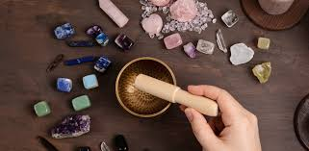

To maintain the effectiveness of your crystals, regular cleansing and charging are essential. Crystals absorb and store energy from their surroundings, which can sometimes become stagnant or negative. Cleansing clears this energy, while charging restores their natural vibrational frequency.

1. **Methods for Cleansing Crystals**

• **Running Water (for durable stones like Clear Quartz and Amethyst):**

Hold the crystal under running water for 1-2 minutes while visualizing negative energy being washed away. (Avoid this method for soft or porous crystals like Selenite or Malachite.)

• **Smudging (suitable for all crystals):**

Pass the crystal through the smoke of sage, palo santo, or incense to cleanse negative energies.

• **Salt Bath (for crystals like Black Tourmaline and Hematite):**

Bury the crystal in a bowl of sea salt for several hours or overnight. (Avoid this for delicate or water-sensitive crystals.)

• **Sound Healing (universal method):**

Use singing bowls, tuning forks, or bells to emit vibrations that clear and reset the crystal’s energy.

• **Moonlight or Sunlight (for charging and cleansing):**

Leave your crystals under the light of the full moon overnight or in sunlight for a few hours. (Be cautious with crystals that fade in sunlight, such as Amethyst or Rose Quartz.)

**2. Charging Your Crystals**

• **Earth Connection:** Bury the crystal in soil for 24 hours to reconnect with the Earth’s energy.

• **Crystal Clusters or Geodes:** Place smaller crystals on a larger Clear Quartz or Amethyst cluster to recharge them.

• **Intentions and Affirmations:** Hold the crystal in your hands, close your eyes, and visualize your desired energy or intention flowing into the crystal.

**3. How Often Should You Cleanse and Charge?**

• After intense use (e.g., healing sessions or emotional work)

• When the crystal feels heavy or dull

• Regularly, at least once a month, during the full moon for enhanced energy

**Building Your Crystal Collection**

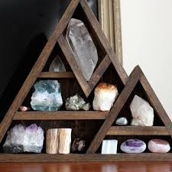

Creating a personal crystal collection allows you to harness their unique energies for healing, manifestation, and spiritual growth. Whether you’re just starting or expanding your collection, here’s a step-by-step guide:

**1. Start with Essential Crystals**

Begin with versatile crystals that cover a range of energies and purposes:

• **Clear Quartz (Amplification and Clarity)**

• **Amethyst (Spiritual Growth and Protection)**

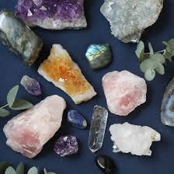• **Rose Quartz (Love and Emotional Healing)**

• **Citrine (Abundance and Confidence)**

• **Black Tourmaline (Grounding and Protection)**

**2. Identify Your Intentions**

Choose crystals that align with your personal goals and emotional needs. For example:

• **For emotional healing:** Rhodonite or Lepidolite

• **For creativity and passion:** Carnelian or Sunstone

• **For spiritual connection:** Selenite or Lapis Lazuli

**3. Sourcing High-Quality Crystals**

• Purchase from reputable metaphysical shops or ethical online sellers.

• Look for natural, untreated stones rather than artificially dyed or enhanced ones.

• Trust your intuition when selecting a crystal—if a particular stone draws your attention, it may be resonating with your energy.

**4. Storing and Displaying Your Crystals**

• **Organize by Purpose:** Keep healing crystals in your meditation space, protective stones near entry points, and manifestation crystals on your work desk.

• **Use Crystal Grids:** Arrange crystals in geometric patterns to amplify energy for specific intentions.

• **Protect Delicate Crystals:** Store soft stones like Selenite or Celestite in a soft cloth to prevent scratching or damage.

**5. Keep a Crystal Journal**

Track your experiences with each crystal, noting any shifts in energy, emotions, or manifestations. This helps you build a deeper connection with your collection and understand how each stone affects your energy.

**Conclusion and Next Steps**

Congratulations on embarking on your crystal healing journey! By understanding the unique energies and spiritual meanings of crystals, you’ve taken a powerful step toward personal transformation and holistic well-being.

**Key Takeaways**

• Crystals serve as energetic tools that can support emotional healing, protection, manifestation, and spiritual growth.

• Regular cleansing and charging are essential to maintain their vibrational power.

• Incorporating crystals into meditation, chakra balancing, and daily rituals can enhance your overall well-being.

• Building a meaningful crystal collection allows you to connect with specific energies and intentions that align with your personal growth.

**Next Steps**

1. **Deepen Your Knowledge:** Continue learning about advanced crystal grids, energy healing techniques, and crystal combinations.

2. **Practice Intuitive Healing:** Spend time meditating with your crystals to enhance your intuition and connection with their energy.

3. **Share Your Journey:** Consider guiding others on their crystal healing path.

4. **Explore New Crystals:** As you grow more attuned to crystal energy, expand your collection with rare and high-vibrational stones like Moldavite or Labradorite.

Remember, crystal healing is a deeply personal and transformative experience. Trust your intuition, stay open to new energies, and allow the crystals to support your spiritual evolution.

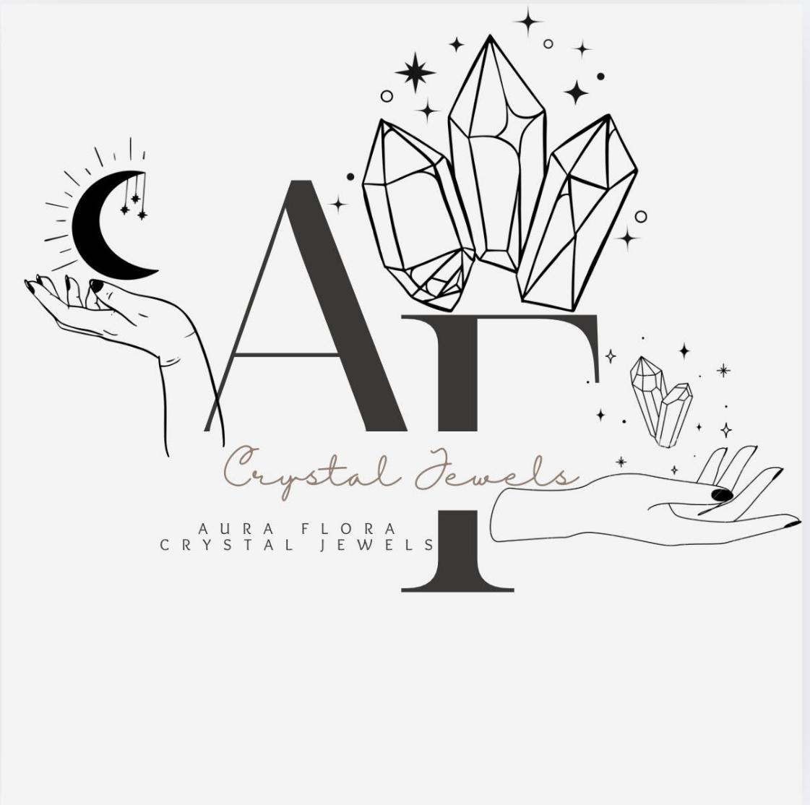

I Hope you have enjoyed this **Power of Crystals for Spiritual Growth and Well-Being eBook.**