**Moldavite: A Comprehensive Guide to Its History, Uses, and Spiritual Meanings**

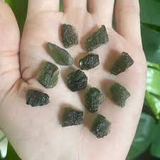

Created by Roxy Slabber – AF Crystal Jewels

Aura Flora Crystal Jewels

**Table of Contents**

1. Introduction to Moldavite
2. Geological Origins
3. Historical Significance
4. Physical and Metaphysical Properties
5. Spiritual Meanings and Healing Benefits
6. How to Use Moldavite for Transformation
7. Caring for Your Moldavite
8. Identifying Genuine Moldavite
9. Common Myths and Misconceptions

10. Conclusion

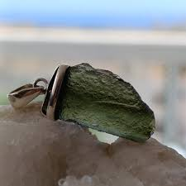

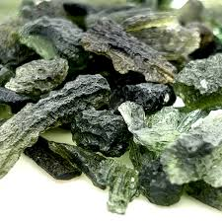

**Chapter 1: Introduction to Moldavite**

Moldavite is a unique and rare green gemstone classified as a tektite. It is renowned for its high vibrational energy and is considered one of the most powerful transformation stones in the metaphysical world. Moldavite’s extraterrestrial origin and deep connection to the cosmos make it highly sought after by spiritual seekers and crystal enthusiasts alike.

**Key Features of Moldavite:**

• Distinctive green colour, ranging from olive to deep forest green.

• Irregular, textured surface due to natural etching.

• Composed of silica glass formed through meteoric impact.

• High vibrational frequency known to trigger spiritual awakening.

**Chapter 2: Geological Origins**

Approximately 15 million years ago, a massive meteorite struck what is now the Bohemian region of the Czech Republic. The intense heat and pressure from the impact melted the surrounding terrestrial material, which fused with the meteorite debris. This molten glass was ejected into the atmosphere and rapidly cooled as it fell back to Earth, forming Moldavite.

**Unique Geological Characteristics:**

• Found primarily in the Czech Republic, with small deposits in Austria and Germany.

• Contains natural bubbles and inclusions due to rapid cooling.

• Often found in irregular, sculpted forms due to natural etching over millions of years.

**Chapter 3: Historical Significance**

Moldavite has been revered for centuries, with ancient civilizations using it for spiritual and protective purposes.

**Historical Highlights:**

• **Ancient Amulets:** Archaeological discoveries reveal Moldavite was carved into talismans and amulets as early as 25,000 BCE.

• **The Holy Grail Connection:** Legends suggest Moldavite was embedded in the Holy Grail, granting divine knowledge and spiritual enlightenment.

• **Medieval Europe:** Moldavite was prized by royalty and spiritual leaders for its mystical properties and connection to higher realms.

**Chapter 4: Physical and Metaphysical Properties**

**Physical Properties:**

• **Colour:** Green hues ranging from pale to deep forest green.

• **Texture:** Rough, pitted surface with natural etchings.

• **Hardness:** 5.5 on the Mohs scale, making it relatively fragile.

**Metaphysical Properties:**

• **High Vibrational Energy:** Known to accelerate spiritual growth and awaken dormant psychic abilities.

• **Transformation Stone:** Helps release old patterns and emotional blockages.

• **Heart Chakra Activation:** Opens the heart to unconditional love and higher consciousness.

**Chapter 5: Spiritual Meanings and Healing Benefits**

**Spiritual Benefits:**

• **Awakens Kundalini Energy:** Stimulates the rise of spiritual energy from the base chakra to the crown.

• **Enhances Intuition and Psychic Abilities:** Aids in connecting with higher dimensions and spirit guides.

• **Facilitates Past Life Healing:** Helps access past life memories and karmic patterns for healing.

**Emotional and Physical Healing Benefits:**

• **Emotional Release:** Clears deep-seated trauma and emotional wounds.

• **Boosts Creativity and Manifestation:** Enhances focus and intention for achieving goals.

• **Physical Healing:** Supports the body’s detoxification process and strengthens the immune system.

**Chapter 6: How to Use Moldavite for Transformation**

**Meditation Practice:**

• Hold Moldavite in your hand or place it on your third eye or heart chakra.

• Focus on your intention and allow the energy to flow through you.

• Use guided visualizations or affirmations to enhance the experience.

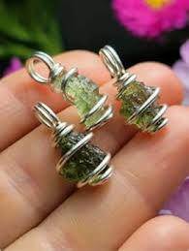**Wearing Moldavite Jewellery:**

• Keeps Moldavite’s energy within your aura throughout the day.

• Rings, pendants, and bracelets are popular choices.

**Creating Crystal Grids:**

• Combine Moldavite with other crystals like Clear Quartz, Amethyst, or Black Tourmaline.

• Set intentions for transformation, protection, or abundance.

**Chapter 7: Caring for Your Moldavite**

**Cleansing Methods:**

• **Moonlight Charging:** Leave Moldavite under the full moon to cleanse and recharge its energy.

• **Sage Smudging:** Pass the stone through sage or palo santo smoke to remove negative energies.

• **Sound Healing:** Use singing bowls or tuning forks to cleanse with vibrational frequencies.

**Storage Tips:**

• Store in a soft pouch or lined jewellery box to prevent scratches.

• Keep away from prolonged exposure to sunlight, which can fade its colour.

**Chapter 8: Identifying Genuine Moldavite**

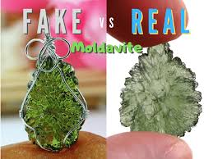

**Authenticity Check:**

• **Texture and Surface Patterns:** Genuine Moldavite has natural etchings and bubble inclusions.

• **Colour and Transparency:** Authentic pieces are translucent green with varying shades.

• **Weight and Feel:** Moldavite is lightweight due to its glass composition.

**Avoiding Fake Moldavite:**

• Be cautious of overly smooth or perfectly symmetrical pieces.

• Purchase from reputable crystal dealers or certified gemmologists.

**Chapter 9: Common Myths and Misconceptions**

**Myth #1: Moldavite is Dangerous**

• Moldavite’s high frequency can be intense, but it does not cause harm. It simply accelerates transformation.

**Myth #2: Only the Spiritually Advanced Can Use Moldavite**

• While powerful, Moldavite can be used by beginners with proper grounding techniques.

**Myth #3: All Green Tektites are Moldavite**

• Other green tektites exist, but true Moldavite is found only in the Czech Republic.

**Chapter 10: Conclusion**

Moldavite is a gemstone of profound transformation and spiritual evolution. With its unique cosmic origins and high vibrational energy, it serves as a catalyst for personal growth, emotional healing, and spiritual awakening. Whether used in meditation, worn as jewellery, or incorporated into crystal grids, Moldavite’s energy can help you align with your highest self and manifest your soul’s purpose

