The Crystal Guide to Self-Love: Unlocking the Power of 10 Healing Crystals

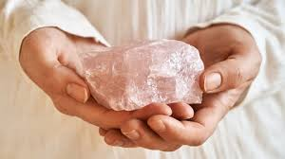

Created By Roxy Slabber

AF Crystal Jewels – Aura Flora crystal Jewels

**Introduction**

In the journey toward self-love, crystals serve as ancient allies that help us tap into our inner strength, heal emotional wounds, and cultivate compassion for ourselves. By working with the unique energy of each crystal, we can shift our mindset, balance our emotions, and unlock the highest version of ourselves. This eBook explores the top 10 crystals for self-love, offering in-depth knowledge, affirmations, and guided meditations for each stone.

1. **Rose Quartz: The Stone of Unconditional Love**

**Description:**

Known as the ultimate heart healer, Rose Quartz radiates gentle, loving energy that opens the heart chakra. It helps dissolve emotional wounds, fosters self-acceptance, and promotes compassion.

**Mantra:**

“I am worthy of love. I embrace my heart’s true essence.”

**Meditation Practice:**

• Hold a Rose Quartz over your heart chakra.

• Inhale deeply and visualize soft pink light filling your chest.

• With each exhale, release past emotional pain and self-doubt.

• Repeat the mantra while feeling warmth and love radiating through your heart space.

**Ritual: Self-Love Bath Ceremony**

1. Run a warm bath and add rose petals and a few drops of lavender oil.

2. Place Rose Quartz in the water or near the edge of the tub.

3. Soak while visualizing the pink energy of the crystal enveloping you in love and compassion.

4. Repeat the mantra throughout the bath.

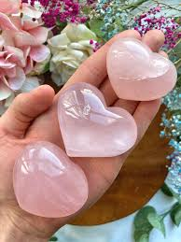

**2. Amethyst: The Stone of Spiritual Growth**

**Description:**

Amethyst’s calming violet hues soothe the mind and connect with higher consciousness. It aids in emotional healing and releases negative thought patterns that block self-love.

**Mantra:**

“I am calm, balanced, and connected to my higher self.”

**Meditation Practice:**

• Place Amethyst on your third eye chakra.

• Breathe deeply and visualize a stream of purple light clearing your mind of self-criticism.

• With each breath, allow wisdom and self-acceptance to flow in.

**Ritual: Emotional Release Candle Ritual**

1. Light a purple or white candle.

2. Hold Amethyst in your hand and write down negative thoughts or self-doubt on a piece of paper.

3. Burn the paper in a fire-safe bowl while repeating the mantra.

4. Visualize the negative energy transforming into light.

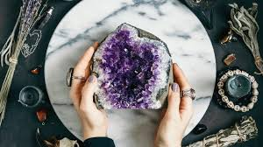

**3. Rhodonite: The Stone of Compassion**

**Description:**

Rhodonite’s rich pink and black hues balance the heart chakra and help release emotional trauma. It is known for encouraging self-forgiveness and inner harmony.

**Mantra:**

“I release the past and embrace my heart’s healing journey.”

**Meditation Practice:**

• Hold Rhodonite in your left hand.

• Visualize past emotional wounds dissolving into soft pink light.

• With each breath, allow compassion and forgiveness to flow through you.

**Ritual: Forgiveness Journal Exercise**

1. Sit in a quiet space with a journal and Rhodonite.

2. Write letters to yourself or others, expressing forgiveness and releasing resentment.

3. Place Rhodonite on the paper to infuse it with compassion.

4. Burn or bury the paper as a symbol of emotional release

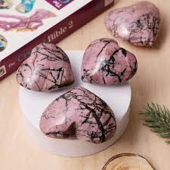

**4. Green Aventurine: The Stone of Self-Worth and Growth**

**Description:**

Green Aventurine is associated with abundance and emotional balance. It enhances confidence and self-worth while dissolving feelings of inadequacy.

**Mantra:**

“I am worthy of abundance and limitless growth.”

**Meditation Practice:**

• Place Green Aventurine on your heart chakra.

• Visualize green energy flowing through your heart, filling you with confidence and self-acceptance.

• With each inhale, draw in positive energy and release doubt with each exhale.

**Ritual: Abundance Manifestation Grid**

1. Create a small crystal grid with Green Aventurine in the centre and clear quartz points surrounding it.

2. Write an intention for self-worth or career growth on paper and place it beneath the grid.

3. Meditate on the grid daily for 7 days, visualizing your intention manifesting.

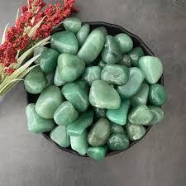

**5. Carnelian: The Stone of Confidence and Vitality**

**Description:**

Carnelian’s vibrant orange energy activates the sacral chakra, boosting self-esteem and creativity. It empowers you to embrace your passions and express your authentic self.

**Mantra:**

“I am confident, creative, and full of life.”

**Meditation Practice:**

• Hold Carnelian near your lower abdomen.

• Visualize a warm, orange glow radiating from your core.

• With each breath, feel your confidence and vitality increasing.

**Ritual: Solar Energy Activation**

1. Place Carnelian in sunlight for 10-15 minutes to charge its energy.

2. Hold the crystal while dancing or moving your body to activate your inner fire.

3. Speak your intentions for creativity and confidence out loud.

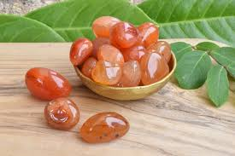

**6. Amazonite: The Stone of Self-Expression**

**Description:**

Amazonite’s soothing blue-green tones calm the mind and open the throat chakra. It helps release self-judgment and encourages authentic self-expression.

**Mantra:**

“I speak my truth with confidence and compassion.”

**Meditation Practice:**

• Place Amazonite on your throat chakra.

• Breathe deeply and visualize blue light clearing your voice and self-expression.

• With each exhale, release fear and allow your truth to flow freely.

**Ritual: Truth-Telling Mirror Exercise**

1. Stand in front of a mirror with Amazonite in hand.

2. Look into your own eyes and speak your truth aloud, such as affirmations of self-worth or setting boundaries.

3. Allow the crystal’s energy to clear fear and encourage authenticity.



**7. Lepidolite: The Stone of Emotional Balance**

**Description:**

Lepidolite’s calming lavender hues soothe anxiety and stress. It contains lithium, which naturally balances emotions and promotes inner peace.

**Mantra:**

“I release fear and embrace emotional harmony.”

**Meditation Practice:**

• Hold Lepidolite in your palm.

• Inhale deeply and visualize soft lavender energy washing over your mind and heart.

• With each breath, allow emotional tension to dissolve.

**Ritual: Stress-Relief Bedtime Ritual**

1. Place Lepidolite under your pillow or beside your bed.

2. Before sleeping, write down any anxious thoughts and place the paper under the crystal.

3. Inhale deeply and repeat the mantra as you drift to sleep.

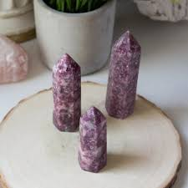

**8. Citrine: The Stone of Self-Empowerment**

**Description:**

Citrine’s bright golden energy activates the solar plexus chakra, boosting confidence and personal power. It helps release fear and embrace joy.

**Mantra:**

“I am confident, radiant, and unstoppable.”

**Meditation Practice:**

• Place Citrine on your solar plexus chakra.

• Visualize golden light radiating from your core, dissolving self-doubt.

• With each breath, feel your inner power expanding.

**Ritual: Prosperity Charging Ritual**

1. Place Citrine in a bowl with coins or money.

2. Speak affirmations of abundance and confidence over the crystal.

3. Carry the charged Citrine in your wallet or workspace to attract prosperity

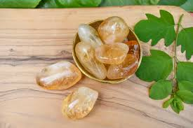

**9. Moonstone: The Stone of Intuition and Inner Healing**

**Description:**

Moonstone’s ethereal glow enhances intuition and emotional balance. It helps release old patterns and supports self-discovery.

**Mantra:**

“I trust my intuition and embrace my emotional journey.”

**Meditation Practice:**

• Hold Moonstone on your third eye chakra.

• Visualize a soft, silvery light illuminating your mind and emotions.

• With each breath, allow your intuition to guide you toward self-love.

**Ritual: New Moon Intention Ceremony**

1. On the night of a new moon, place Moonstone on your altar.

2. Write your self-love intentions on paper.

3. Meditate with Moonstone while visualizing your desires manifesting.



**10. Black Obsidian: The Stone of Protection and Shadow Work**

**Description:**

Black Obsidian is a powerful grounding crystal that absorbs negative energy and protects against self-sabotage. It supports deep emotional healing and shadow work.

**Mantra:**

“I release fear and embrace my true power.”

**Meditation Practice:**

• Place Black Obsidian at your feet or root chakra.

• Visualize black energy pulling away all negative emotions and self-limiting beliefs.

• With each breath, feel grounded and empowered.

**Ritual: Grounding Release Ritual**

1. Bury Black Obsidian in the earth overnight to clear stagnant energy.

2. Perform deep breathing exercises while holding the crystal to ground yourself.

3. Visualize releasing old patterns and limiting beliefs into the earth.

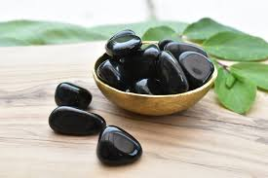

**Conclusion**

By working with these 10 powerful crystals, you can unlock the path to deep self-love, emotional healing, and spiritual growth. Regular practice with these stones, along with intentional meditation and affirmations, will help you shift your mindset and embrace your true essence.